**Data Visualization using R**

Task 1 a.

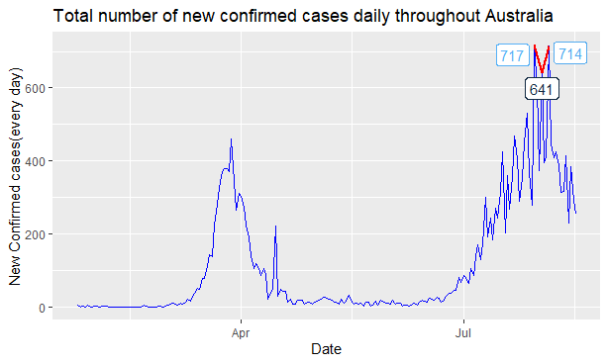

This visualization is illustrating the new confirmed COVID-19 cases since 25 January 2020 when first case was recorded. It shows the cumulative count of cases in all eight states throughout Australia. I have used a line chart to show the changes in new confirmed cases over time. Coloring has been used to discriminate between three highest numbers of cases and rest of the cases. To provide more clarity count of highest confirmed cases in a day has been shown in the graph.

Task 1 b.

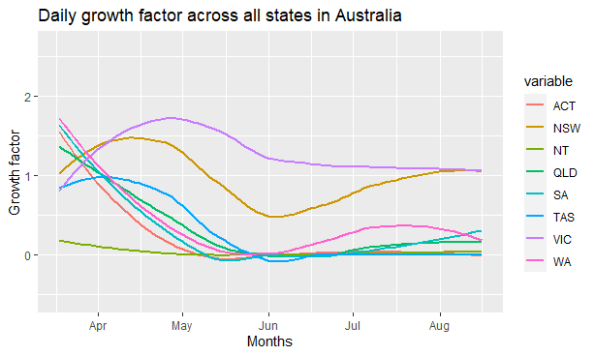

This visualization is showing the growth factor of COVID-19 cases in all eight states. I have used line chart (**geom_smooth()** function) to plot the change of growth factor over the period of 17 March 2020 to 16 August 2020. Colouring has been used to differentiate between the states.

Task 2 a.

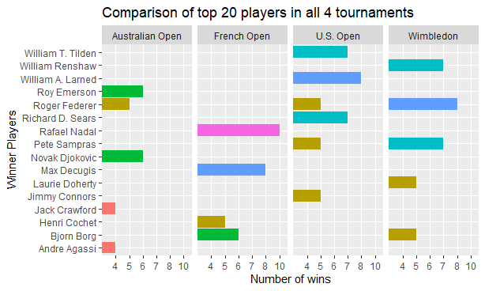

This visualization is showing the comparison of the performances of top 20 winners for each of the four Grand Slam tournaments (Australian Open, French Open, and Wimbledon, U.S. Open). I have used bar charts (**bar charts()** function) to show the comparison of winners in all four tournaments . Colouring has been used to differentiate between the numbers of winners in each bar chart.

Task 2b.

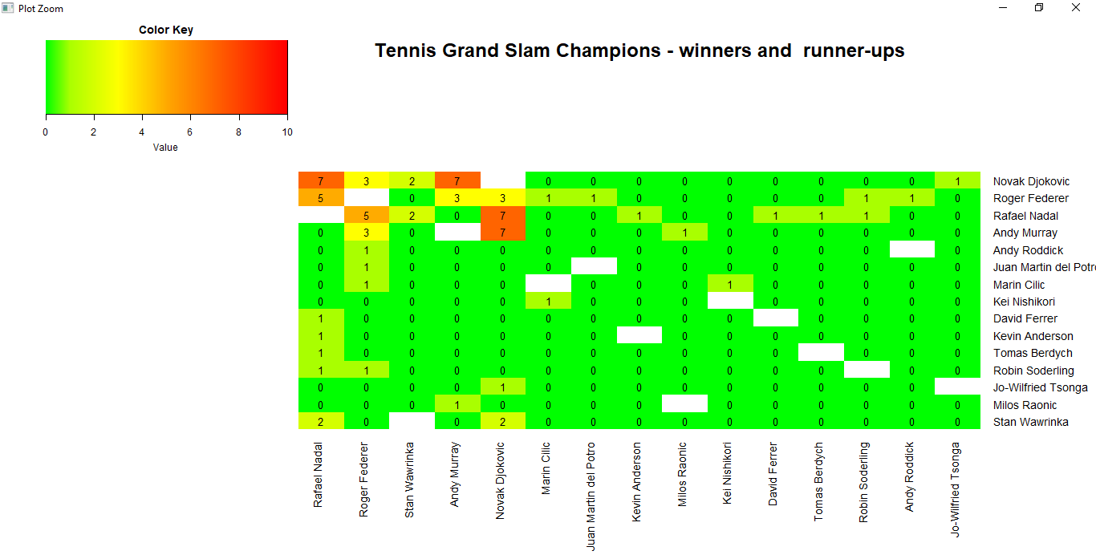

This visualization is highlighting how many times the winners and the runner-ups met each other on each of the Grand Slam tournament finals for the 40 most recent tournaments. I have used heat map (**heatmap.2()** function) to show winners and the runner-ups. Colouring has been used to show the values (counts of winners and the runner-ups meeting each other).

Task 3.

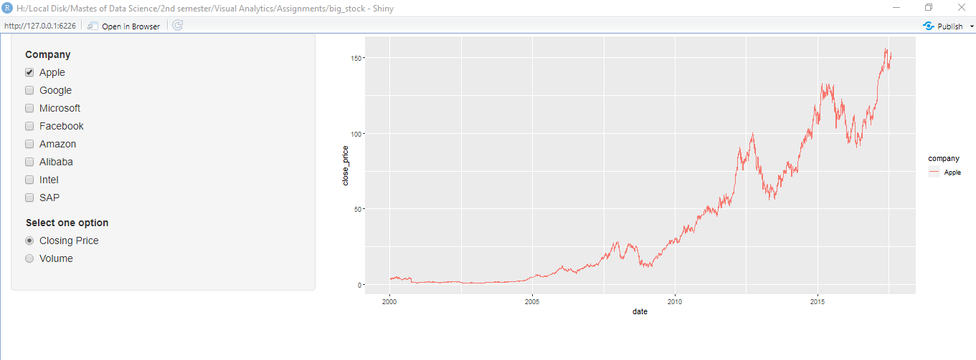

This visualization is showing the change over time of a chosen share based on either the closing price or the share volume. It also compares the shares performance between two or more companies. I have used line chart to show the companies stock market data (closing price and volume) over the period. Colouring has been used to differentiate between the companies.

Task 4.

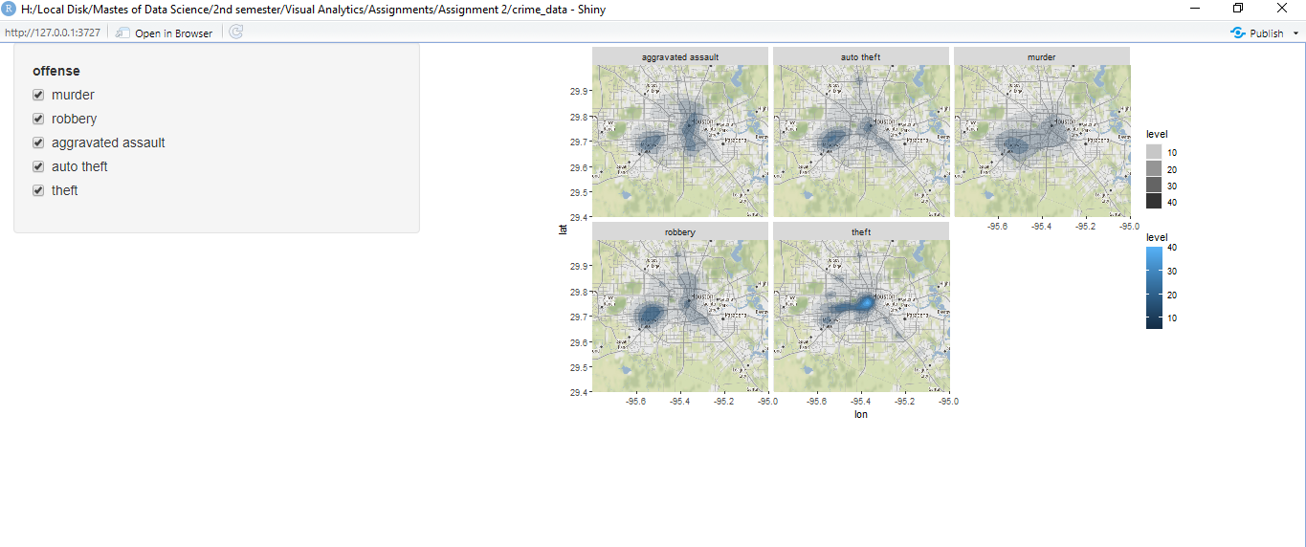

This visualization is showing the spatial density of one or more offense types in the Houston area for a time period. I have used maps (**ggmap()** function ) to show the comparison of all offense in the Houston area. Colouring has been used to show the level of crimes.